- Create a shell script to print the HTTP error code of guvi.in & print, the success/failure message based on the error code response
#!/bin/bash
URL="https://www.guvi.in"
HTTP_CODE=$(curl -s -o /dev/null -w "%{http_code}" "$URL")
if [[ -z "$HTTP_CODE" || "$HTTP_CODE" == "000" ]]; then
echo "Error: Could not connect to the server."
elif [[ "$HTTP_CODE" -ge 200 && "$HTTP_CODE" -lt 300 ]]; then
echo "Success! HTTP Status Code: $HTTP_CODE"
else
echo "Failure! HTTP Status Code: $HTTP_CODE"
fi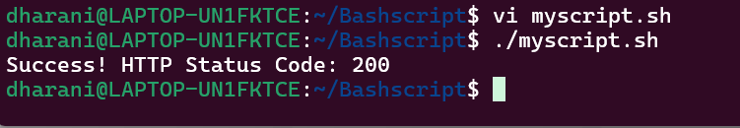

- Given a file, replace all occurrence of the word "give" with "learning" from 5th line till the end in only those lines that contain the word "welcome"
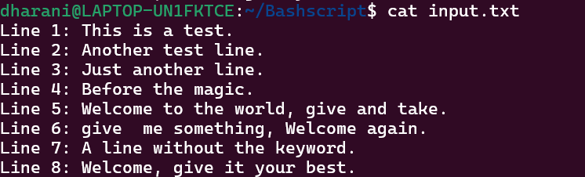

Code: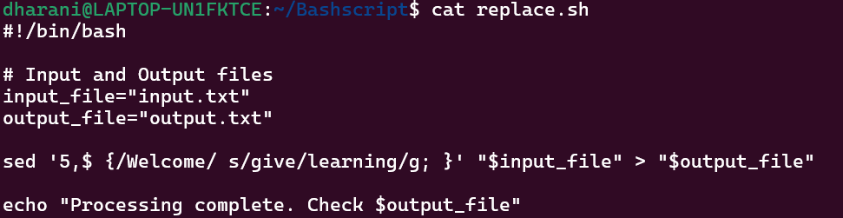
Output –
